**Q1: Simulation in excel**

By using the following formulations to generate intra-arrival time and service time duration for each customer, the simulation result can be obtained in excel.

$intra arrival time= -\ln\left(1-rand\left(∙\right)\right)*1/0.3$ (1)

$service duration time= 2*rand\left(∙\right)+2.5$ (2)

1. 35 customers are served per day;
2. Total delay per day is 278.61 min;
3. Average delay per customer is 7.96 min.

**Q2: Cumulative arrival and departure**

$CA=\left\{\begin{matrix}8t & 0≤t≤30 \\ 2t+180 & t>30\end{matrix}\right.$

$$CD=\begin{matrix}5t & t≥0\end{matrix}$$

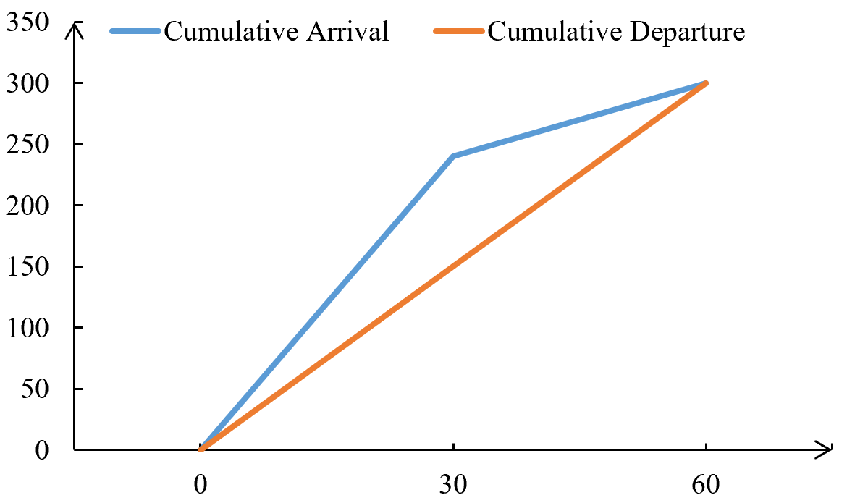

Figure 1 Cumulative arrival and departure

$2t+180=5t$ $t=60$

So, the queue will disappear at 60min.

1. Total waiting time $T_{total}=\frac{1}{2}×90×30+\frac{1}{2}×90×30=2700 min$

Average queue length $L_{ave}=2700/60=45$

Average waiting time $T_{ave}={2700}/{300}=9 min$

**Q3: Car following**

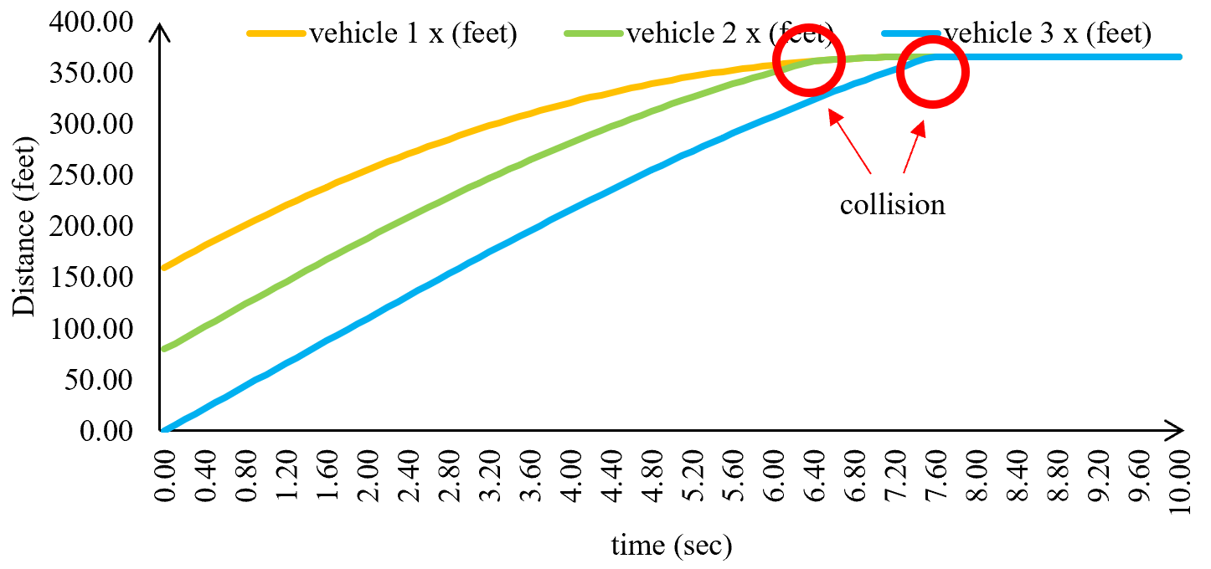

Figure 2 Vehicle trajectories

Please refer to excel file for detailed calculation process.